Design Document for:

Antibody





Race against time to stop the Nano-virus infection!

All work Copyright ©2017 by Antibody

Written by Joe O Regan, Sean Horgan & Brian Ryan

Version # 1.00

Name of Game 1
Game Overview 4
Design Goals 4
Design Goal #1 4
Design Goal #2 4
Design Goal #3 4
Design Goal #4 4
Common Questions 4
What is the game? 4
Why create this game? 4
Where does the game take place? 4
What do I control? 5
How many characters do I control? 5
What is the focus? 5
What’s different? 5
Feature Set 6
General Features 6
Game play 6
The Game World 7
Overview 7
World Feature #1 7
World Feature #2 7
The Physical World 7
Travel 7
Scale 7
Objects 7
Time 7
Rendering System 8
Overview 8
Camera 8
Overview 8
Game Engine 8
Overview 8
Collision Detection 8
Game Characters 9
Overview 9
Enemies and Monsters 9

User Interface 10
Overview 10
User Interface Detail #1 10
Weapons 11
Overview 11
Weapons Details #1 11

Musical Scores and Sound Effects 12
Overview 12
Red Book Audio 12
3D Sound 12
Sound Design 12
Single Player Game 13
Overview 13
Story 13
Hours of Game-play 13
Victory Conditions 13
Character Rendering 14
Overview 14
Extra Miscellaneous Stuff 15
Overview 15
Junk I am working on… 15
“XYZ Appendix” 16
“Objects Appendix” 16
“User Interface Appendix” 16
“Networking Appendix” 16
“Character Rendering and Animation Appendix” 16
“Story Appendix” 16

Game Overview

Design Goals

Design Goal #1

From the very beginning we decided that we wanted this game to be different and unique from the rest of the racing games that are on the market. We wanted to try and create a racing game that would stand out from the crowd and which would give us some individuality.

Racing games can lack variety and inspiration. They all have their own personality but many are
just cars racing against each other or against time. Our game aims at showing how ‘out of the box’ racing games can be improved. A lot of racing games don’t have much of a story either, we feel by adding a story to the game it can help the player feel an attachment to the game, and want to succeed and complete each task and level.

Design Goal #2

We wanted to create a fast-paced environment with lots going on and plenty to keep the player occupied, not just race from A to B in X amount of time. We wanted to add variety to try and keep the player interested.

Design Goal #3

This must be a fun and interesting game for several reasons, namely to attract player attention and to keep the developers interested in progressing the game form concept through to delivery of finished product.

Design Goal #4

We wanted to add a lot of unique features, and we think we have accomplished this by adding the score text displaying the score value for each enemy object the player has destroyed on the screen. This score text tracks the player movement and moving towards it giving a nice visual effect.

We also added the rocket weapon with player controlled movement, to separate this from the other weapons we created, the Laser and Ninja Star that have only basic forwards straight line movement.
Common Questions

What is the game?

A racing game in which the player pilots his ship, which can shrink to a size that enables him to navigate inside his genius friend’s bloodstream. The player must race through the bloodstream, navigate around obstacle’s, avoiding blood cells, fighting viruses, and enemy Nano-bots. The player must race against time, and compete against enemies, to complete levels.

The player can gather power-up objects along the way for health, new lives, weapon upgrades, add rockets to their inventory, or bonus time can be added by collecting the checkpoint power up. The player can upgrade their main Laser weapon, which has three different grades, single, double, and triple beam.

The boss enemy which we are working now will track the player movement on the screen intermittently moving out to attack, firing laser beams from its eyes. Spawning Enemy Virus objects from its mouth. The aim of each level will be to get the end of the level and kill the level boss.

Why create this game?

The purpose of this project is to develop a racing game, as a team, that is of such a standard where it is a competitive entry for Games Fleadh, and is also worthy of winning an award. We also, expect to improve our knowledge of OO design and development methods. We can then apply that knowledge to our approach to making a game.

The best way to learn is by doing, and the work we put in so far has backed up our opinion that it would be a great benefit to us, boosting our programming knowledge. And helping us practice meeting strict deadlines, while also having our work judged by more people with a lot more experience, who can provide us with helpful feedback.

Where does the game take place?

This game will take place in the bloodstream of a human body, specifically the bloodstream of our genius scientist friend who we are desperately trying to save in time! As the player pilots the ship through the professor’s blood vessels he will encounter red and white blood cells, and enemy nano-bot and virus objects. As the player navigates through the body, we hope the map we are implementing will indicate the current part of the body the player is in.

What do I control?

The player will control a ship with attack capabilities which has been shrunk in size to fit in the blood stream of a human body.

How many characters do I control?

You will control one ship using either the keyboard or an optional controller. The game has been developed with controller support. The player also can control an additional rocket weapon. The player can upgrade the weapons of this ship, but there is no visible changes to the aesthetics of the ship as the game progresses.

What is the focus?
The focus is to get to the final level and destroy the virus that is harming our scientist friend the professor. We concentrated on creating an original soundtrack, and trying to pack in as many features as we could, but ultimately, we hope the gameplay itself will stand out.

What’s different?

We feel by combining the side-scrolling shooter game idea of a game like R-Type with the idea of a racing game, with checkpoints, battling against the clock, and racing against enemies, will refresh a previously successful but old idea, and make our racing game more exciting, and engaging for the user.

We also believe the weapons we have created such as rockets, with player controlled movement and added something different. Also, the Blue Virus satellite projectile object with a countdown timer before it fires, giving a randomness the player has to cope with, and the more predictable yet devastating Exploding Orange Virus that sends projectiles in 8 different directions add to the gameplay experience.

We have added scores that spawn when a player destroys an enemy object, and move toward the ship of the player who has scored the points. Highlighting the scores with different colours, but keeping the scores a bit low key and slightly in the background by lowering the alpha value.

We added a range of sound effects, separate sound effects for each player to distinguish between the weapons being fired with distinct sounds for player Laser and Ninja Stars. We also added distinct explosions for Green, Orange, and Blue Viruses, matching the individual colours of the Virus that’s been destroyed, and also a red explosion for Blood Cells, as the larger blood cells can also be destroyed by the Ninja Star spinning projectile weapon.

The tracker movement we used for the displayed scores for each object we also used for the White Blood Cell, it moves along the screen slowly up and down like tumbleweed drifting across the scenery in a Western until a virus is split in two. Then it moves in to sweep up the easier to manage smaller size of the Small Virus.

Feature Set

General Features

- Side scrolling parallax racing adventure
- Many different enemies with AI
- Many different weapon choices
- Power up options
- Time trial levels
- End of game boss
- Single player or two players
- Original music
- Distinct sound effects, particularly for each player
- Player controlled rocket weapon with timer to build up power deciding the score value
- Heads up display giving visual indication of the players rocket inventory, laser grade, score, lives, the mini-map, and speed boost indicator
- Random message generation for spawning and beginning levels

Gameplay

- Fast paced racing adventure game
- Randomly spawned enemies with AI
- Different types of enemies with different attacks
- Obstacles in different levels
- Speed boosts
- Health Packs
- Extra lives
- Ninja Stars
- Saws
- Player controlled rockets
- Multiple laser type’s
- Timer based Virus enemy projectile spawning and explosions

The Game World

Overview
The bloodstream of our scientist friend the professor. Red & white blood cells, enemy virus and Nano bots.

World Feature #1

Completely new and original idea/concept for a game world/racing game.

World Feature #2

Detailed artwork of blood cells/viruses and cholesterol blockages of the blood stream.

The Physical World

Travel

Player can use keyboard or game pad controllers to move the player around the screen. Up, down, forwards or backwards. All the buttons on the game pads are utilized to enable different elements of control.

Scale

The game is side scrolling and all the main viewing window will take the form of a vein/bloodstream of the human body. The player will control a tiny ship which has been implanted in this body to get to the cause of the virus which is infecting it.

Objects

- Player ship
- Weapon Power ups
- Health Power ups
- Extra Lives
- Added time power up
- Red & White blood cells
- Different types of enemy virus
- Nano Bots

Time

Time is used in the game by counting down, the player will need to collect the time power ups to enable them to continue in the game and progress.

Rendering System

Overview

This game will be rendered by using C++ and leveraging the power of SDL into a beautifully created 2D adventure, complete with all original artwork.

Camera

Overview

The camera is set to parallax motion, therefore the camera follows the player as the background scrolls

Game Engine

Overview

Programmed from the ground up using C++ and SDL.

Collision Detection

For collision detection, we are using Axis-Aligned Bounding Boxes checking the edges of the objects against each other. Different collisions trigger different events depending on the object. With objects rebounding off the sides of the blood vessel to stay on the screen. With player weapons only destroying enemy objects and vice versa.

Different weapons need to be active when colliding with different enemy objects, such as Ninja Stars and Saws will split Virus objects in two, with the ninja star more useful for long range attacks on exploding viruses. They can also be used to destroy large blood cells. Only the player saw will cut through blockages, if the saw is not active the player will be pushed back by the blockage.

Game Characters

Overview

Player character is a ship like a miniature space ship you might see in a space shooter game. The back story before levels will create the scene for the player.

Player Ship


Figure 1 Player Ships for players 1 (orange) and 2 (green)

The player pilots the ship (Figure 1) through the level, it has a range of weapons that can be upgraded as the level progresses. There are different colours to distinguish Player 1 from Player 2, each ship has distinct weapon colour, with green lasers for the green ship, and yellow lasers for the orange ship. This is the same with Ninja Stars.

Enemies and Monsters

Many different types of enemies, different viruses, Nano bots and cholesterol blockages. Also, an end of game boss that must be defeated. The virus enemies can shoot projectiles at the player ship.

Nano-bot

The Nano-bot (Enemy Ship Figures 2 & 10) has basic movement and weapon firing, with ship itself moving in a straight line right to left with the y coordinate never changing as it moves across the screen. It fires lasers with a random spacing between them, this is the only AI for this basic enemy. When the Nano-bot enemy is spawned, it is assigned a random velocity, to make them a little bit less boring. It has a score value of 25 points.


Figure 2 Nano-bot (Enemy Ship)

Green Virus

The Green Virus (Figures 3 and 11) is the most basic enemy virus. It has a random spawn speed and tracker movement, or stalker movement as we called it, that allows the virus to move towards the nearest player on the screen by calculating the Euclidean distance between itself and the two players on screen in two player mode, and switching adjusting its Y coordinate value to match that of the player ship. Once it moves past both players it ignores them and continues moving right to left. The green Enemy Virus has a lower point score of 10, as it moves in front of the player, and has no projectiles to worry about.


Figure 3 Green Virus Sprite Sheet. A similar sprite sheet is used for Orange and Blue Virus enemies

Exploding Orange Virus

The Orange Virus (Figures 4 and 12) has all the features of the Green Virus but it includes a countdown timer of 3 seconds, this is represented by a status bar at the side of the virus. When the timer reaches 0 the Orange Virus explodes, sending projectiles in 8 different directions.

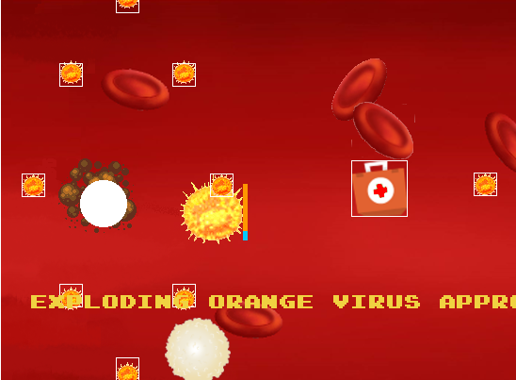
Figure 4 Orange Exploding Virus showing one exploding while another timer is counting down, the rectangles indicate the colliders for some of the objects

Blue Virus with Satellite Projectile

The Blue Virus (Figures 5 and 13) is a slight variation on the Exploding Orange Virus. When the Blue Virus timer runs out, it spawns another satellite projectile. The projectile will only fire after orbiting the virus once. When the timer reaches zero, another projectile will be spawned.

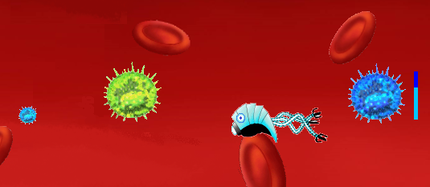
Figure 5 Blue Virus with Orbiting Projectile firing

End of Level Boss

At this current moment in time, only one Enemy Boss has been created. As the artwork was based on one of our class mates we have not been able to include it, as he wasn’t 100% happy with the idea. One of the other class mates offered to take his place in the game. We basically took a Facebook picture, and cartoon-ised it, adding an animated mouth that should spit out Enemy Virus objects at the end of the level.

The Professor

The professor (Figure 6) is a really a minor a character as far as game events go. We have used him as the sprite to represent the game map. This will indicate the player movement as he moves through the body. The map can be enlarged by pressing the keypad. This allows you to see how far you are into the level, but still play the game by setting the alpha value lower for a transparent view. We used a stock image from the internet for this character.
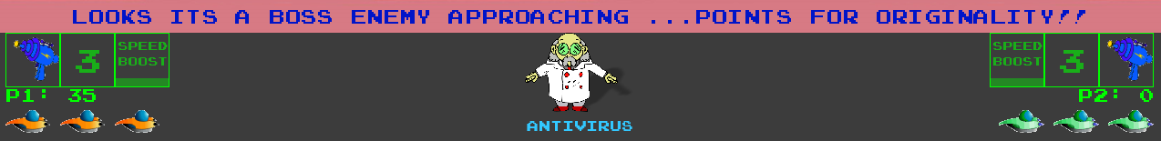

User Interface

Overview
The UI is easy to understand and follow, giving the player complete control of the menu system. Each area compliments the other and allows 100% accessibility for the player.

User Interface Detail #1

The main menu has 6 buttons, story, 1 player, 2 players, settings, high score and quit. Story, starts the game with the background story and information screens, explaining what the game objects do. 1 player starts the game with only 1 player, and 2 players is obviously the game played with 2 players. The settings and high scores have yet to be implemented.

Whilst in game there is the main viewing window where the game takes place and there is also a HUD which displays the player’s health, current weapon, score and position on map. The laser indicates the current grade of laser, single, double, or triple beam laser. The rocket indicator indicates the current number of rockets a player has, while the speed boost icon indicates the time remaining for speed boosts.

The professor icon represents the game mini-map. This can be enlarged to view and enlarged transparent map, to monitor the progress through the level.

Weapons

Overview

There are several different weapons available throughout the game. Player starts with a simple laser and can acquire new weapons through gathering power up’s during the level.

Weapons Details #1

- Standard Laser
- Multi Direction Laser
- Ninja Stars
- Saw
- Rockets

Musical Scores and Sound Effects

Overview

Using the SDL_mixer library we added sound for effects and music. SDL uses Mix_Music for longer audio clips such as sound, and Mix_Chunk for short clips for in game effects.

Music

We first inserted some mp3 and wav files we had lying around on our own computers to check we had the functionality working. We then began the process of creating our own original recordings for the game.

Joe used Guitar Pro 6 to tab out some music tracks, including guitar, drum, and bass parts. With Guitar Pro, you can tab out the notes for the song, loop repetitive parts or riffs, and when done, export to a wav. This can then be compressed using mp3 or OGG format. Joe’s brother Jim showed him a few tricks to get started, and also included a song as part of our soundtrack.

While Sean used a similar method to record with the computer.

The music tracks are stored in a vector, the tracks can be skipped by pressing the k or l buttons on the keyboard, or by using the trigger buttons on the control pad. The track title and composer are displayed on screen as the tracks are skipped through.

Sound Effects

For sound effects, we downloaded samples from free sound effect websites, we altered the pitch of the sound effects for laser, and ninja star effects, to give distinct sounds for each player.

Red Book Audio

We are not using Red Book Audio exactly, instead we are using a mixture of mp3 and wav files in the game.

3D Sound

We used SDL_mixer, but hadn’t time to look into any third party sound APIs.

Sound Design
While most of the music soundtrack has been composed by ourselves with some help from people we know. The audio effects have been downloaded and manipulated using programs such as Audacity.

We found that the pitch of the effects needed to be higher for them to be noticed above the music. Increasing the pitch allowed for the effects to more distinct, and adding a different level of pitch to the sound effects allows further distinction between players.

We would have liked to have add stereo sound to indicate the sound travelling across the screen from left to right as you listen in stereo or surround sound, panning the sound left to right to match object movement. The implementation for this looks straight forward with SDL, but we just don’t have enough time with tying all the features together.

We use a singleton to access the Audio class from within the game for playing sound effects and music. The Audio class loads all the sound files when the game initializes. These sound files can then be accessed through a single instance of the Audio class throughout the game.

Single-Player Game

Overview

The single player game is a fast & frantic race through the bloodstream, defeating virus enemies and Nano-bots, collecting power ups and extra time to allow the player to progress.

Story

The game is set in the bloodstream of our scientist friend. He has been infected with a virus by an evil doctor and we must use our ships to get to the source of the virus and save our friend.

Hours of Gameplay

6 minutes!!!! Not hours!! We have 3 levels in the game, with each level timed at 2 minutes. Collecting time bonus power ups, will extend the countdown clock by 20 seconds.

Victory Conditions

Acquire added time power ups to continue in each level. Get to the end of each level and progress further. Final level boss will need to be defeated to beat the game.

Along the way, the player will need to overcome or avoid deadly Virus enemies, with different abilities. Nano-bots and Virus enemies, and blockages will act as obstacles to the player in trying to complete the level.

Character Rendering

Overview

Player ship is rendered using the SDL image library. SDL_image library is used to load texture and surface structures for use in the game, that are not in bitmap format, we mostly used PNG images. SDL_ttf library is used to generate in game text, along with the string library for creating text strings, and stream library for creating constantly updating text strings such as the game timer and FPS indicator.

The Texture class manages all the texture functionality, such as modifying the alpha values for flashing objects, such as when the player spawns. It loads the images and has separate render functions for rendering static and animated images. The player ship itself is a static texture, but the Enemy ship (Nano-bot) and Virus use sprite sheets for animation.

Animation is rendered using frames, the frames are created from the sprite sheet by only displaying a portion of the image at a time, using source and destination rectangles, the number of frames required, and the speed can be adjusted to slow up or down by adjusting how the refresh rate is applied mathematically.

Text is created using SDL functions to create a surface from the text, then converting it to a texture. SDL_Textures use hardware to accelerate the performance, while surfaces do not. Rendering text caused a lot of problems with memory leakage, and it took two days of going through the code, to first isolate the problem, then solve it. We fixed the problem, by ensuring text is only generated when the values change or update.

Extra Miscellaneous Stuff

Overview

We would have liked to have implemented proper stereo sound to indicate object movement etc. Other things we were working on but haven’t finished include a straight up race mode, where the players sprint towards the end of the level with separated cameras in a split screen mode, with ghost ships indicating the opposing player on their individual screens. Some other ideas are stated below.

Junk I am working on…

Practice Mode

A target practice area for practicing firing different weapons, particularly rockets which have player controlled movement. Using the gamepad, the player can control the movement of the rockets with the left thumb stick. There is also keyboard movement using the “+” and “-“ keys. Adding a practice area so the player can practice the skill of controlling the rocket slowly building up from 1 enemy to a greater number of enemies

Player Ship Shield

A shield that is bubble like in appearance, that deflects enemy projectiles away at different angles depending on the point of contact and angle of entry. This would add more realism, and give the player a better way to defend themselves in later levels as the number of Enemy ships and Virus continue to grow

Upgraded Enemy Ships

As the levels progress, it would be more interesting the Nano-bot enemy ships had smarter movement or better weapon technology. We would like to add an upgraded weapon using the same tracking method used for the Score Text for tracking player movement to have weapons track the player(s) as the ship moves around the screen.

A More Detailed Menu System

Because a lot of the game has been done since before Christmas, and there has been constantly been about the same amount of code since then in our main Game.cpp file as fine tune features before separating them out into their own classes, the menu system, and trying to convert the game to a Finite State Machine became a bit harder than expected.

Not every piece of code wanted to cooperate with the move to an FSM. So, this has been left to one side as fixing up the playing experience and all the bugs we have created ourselves has become the priority.

Straight Up Race Mode

We have most of this implemented, but there was an issue with the backgrounds not matching up exactly when the players are beside each other on the different screens, despite being in the same position.

We implemented ghost characters for the opposing player, and we had separate camera movement in split screens. The only real bug was the background position.

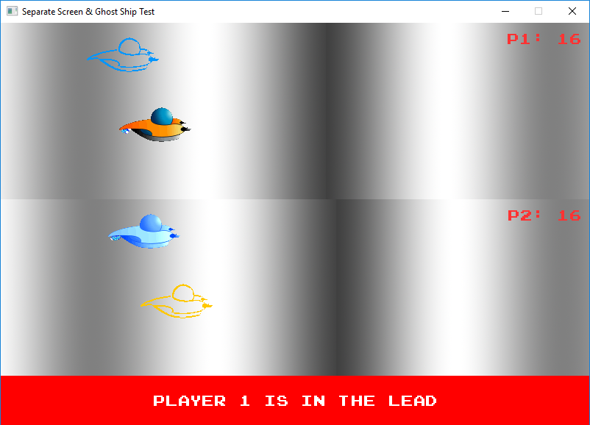
Figure 6 Race Mode testing phase with ghost ship, timers and separate camera views implemented

“XYZ Appendix”

The appendices include some of the images and sprites we have used to represent objects in our game. The following appendices include some examples.

Original Tracks

Also, the music we included has some original tracks, from Sean Horgan, Joe O’Regan, and Jim O’Regan. The songs in the track listing include:

- The First Step by Jim O’Regan
- Virus by Joe O’Regan
- Bloodstream by Sean Horgan

“Objects Appendix”
We used a different textures and animations to represent game objects, here are some of the objects in our game. Including:
- Blockage
- BloodCell
- Nano-Bot / EnemyShip (Figure 2)
- Blue Enemy Virus (Figure 5)
- Green Enemy Virus (Figure 3)
- Orange Enemy Virus (Figure 4)
- Ordinary Explosion (Figure 14)
- Blood Explosion (Figure 15)
- Blue Explosion (Figure 16)
- Green Explosion (Figure 17)
- Orange Explosion (Figure 18)
- Blue Laser (for Nano-bots) (Figure 19)
- Green Laser (for Player 2) (Figure 19)
- Orange Laser (for Player 1) (Figure 19)
- Laser Upgrade Double Beam
- Laser Upgrade Triple Beam
- Ninja Star Player 1
- Ninja Star Player 2
- Player Ships (Figure 1)
- Timer Power Up
- Health Power Up
- Laser Power Up
- New Life Power Up
- Rocket Power Up
- Professor (Figure 6)
- Saw
- Virus Fireball
- White Blood Cell

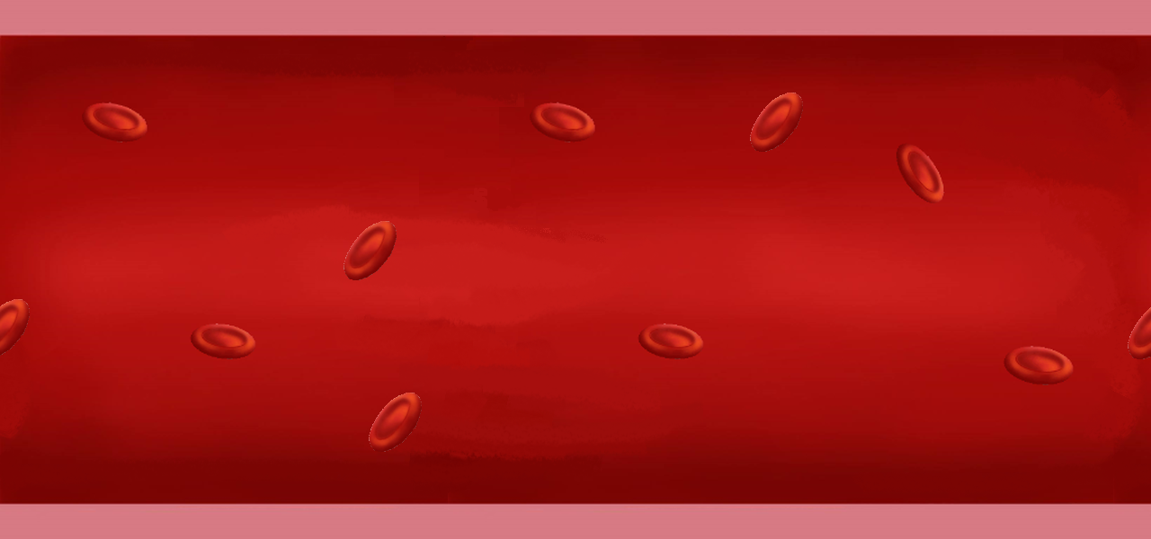
Figure 7 Background image used in the game

“User Interface Appendix”
The user interface including the menus and heads up display have a range of functionality. The menu and progress from menu to playing and playing to ingame / pause menu, would have been a lot smoother with a more technical state mechanism, but time constrictions didn’t allow for it.

Menu: The menu (Figure 7) can be interacted with by using a mouse, clicking the buttons brings you to the different options listed on the screen. The options include:

- Story: start the game with the animated story introduction splash screens
- 1 Player: start the game in 1 player mode
- 2 Player: start the game in 2 player mode
- Settings: settings not yet implemented, but different keys assigned in game
- High Scores: not yet implemented
- Quit: quits the game, closing the game window

Heads Up Display: The heads up display shows
- Current Laser Grade
- Number of rockets in player inventory
- Speed boost indicator, with timer status bar
- Player score
- Number of lives left
- Professor mini-map
- Game creators rendered animated text

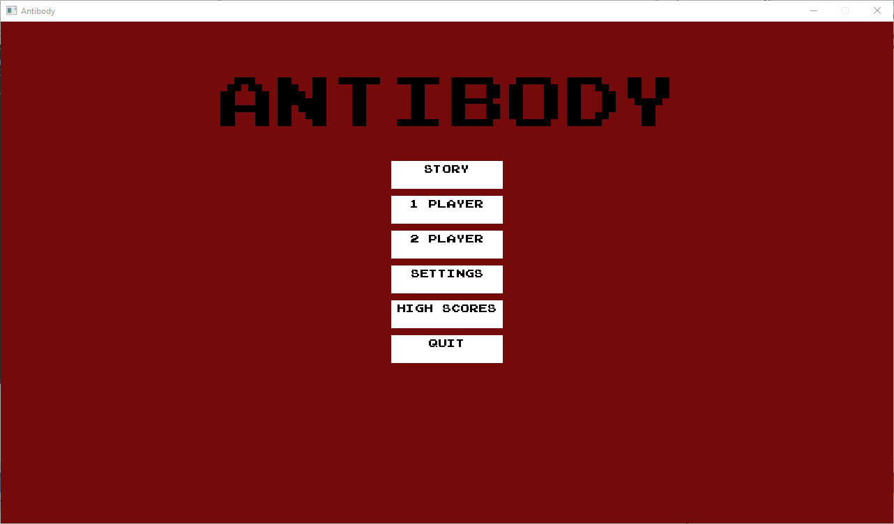
Figure 8 Main menu screen

Figure 9 Heads Up Display, with visual indicators for lives, inventory, weapons grade, mini-map and score

“Networking Appendix”
We didn’t get around to adding networked play to the game unfortunately.

“Character Rendering and Animation Appendix”
Sprite sheets for animations, including:
- Nano-bot / Enemy Ship (Figure 10)
- Green Enemy Virus (Figure 11)
- Orange Enemy Virus (Figure 12)
- Blue Enemy Virus (Figure 13)
- Explosion (Figure 14)
- Red Explosion for blood splatter (Figure 15)
- Blue Explosion (Figure 16)
- Green Explosion (Figure 17)
- Orange Explosion (Figure 18)

For the explosions we downloaded a red explosion animation from Vicente Molinas website https://vicentemolina.neocities.org/animation/animation.html and used IrfanView and paint.net to alter the colours for green, orange, and blue virus explosions.

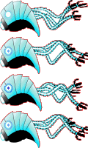
Figure 10 Nano-bot / Enemy ship sprite sheet

Figure 11 Green Virus sprite sheet, gives glowing effect


Figure 12 Using the original image provided by Indie Macernyte we created animated Virus sprite sheets in 3 different colours


Figure 13 Blue Virus sprite sheet

Figure 14 Explosion Sprite Sheet

Figure 15 Red Explosion for blood splatter effect

Figure 16 Editing the colour of the original blood splatter animation by Vicente Molina gave us explosion effects for the Virus enemies

Figure 17 Green Virus explosion / splatter sprite sheet

Figure 18 Orange Virus explosion / splatter sprite sheet

Weapons

Weapons include lasers (Figure 19), ninja stars, rockets and saws for players, and lasers, fireballs, and orbiting projectiles for enemies.

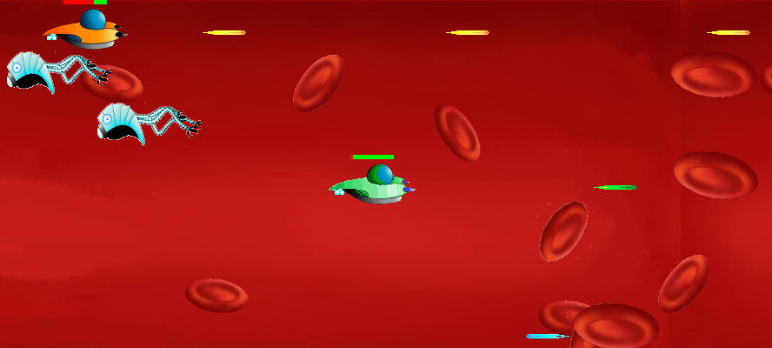
Figure 19 The player laser can have single, double or triple beams

“Story Appendix”

We used scrolling splash screens to explain the plot, the following are examples from the intro screens to Level 1, with a 3-page story (Figures 20, 21, and 22), and an objectives page (Figure 23).

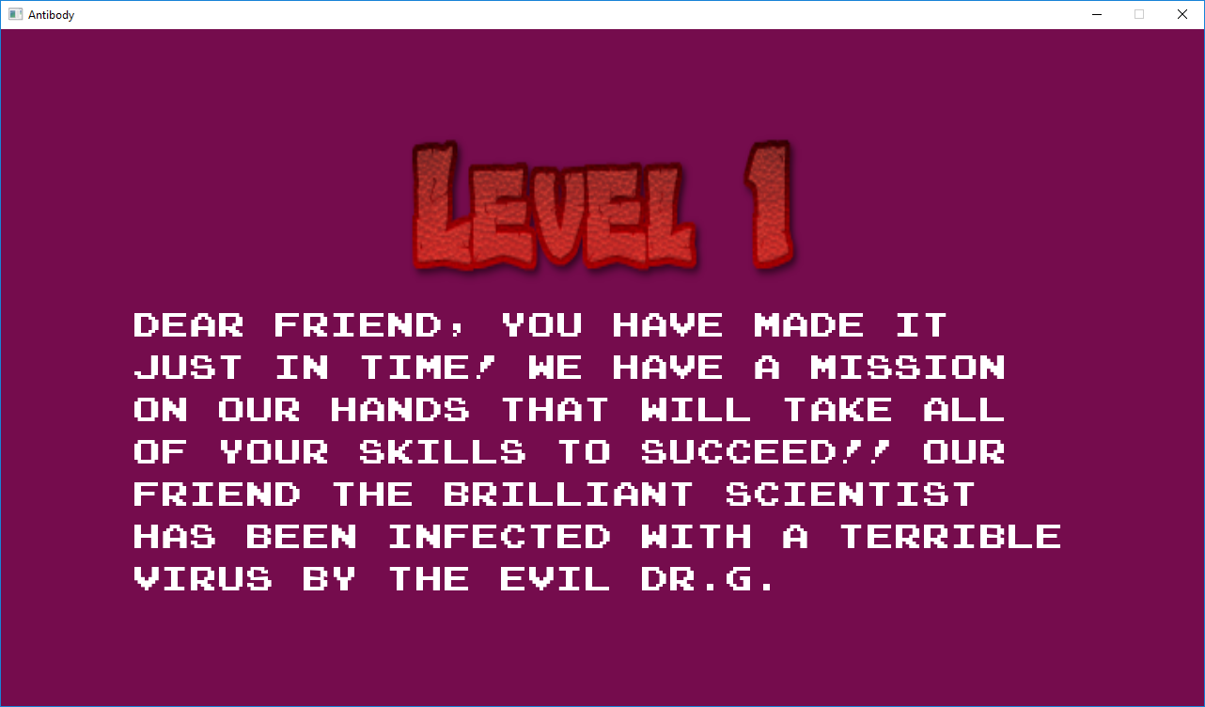
Figure 20 Level 1 Story Screen 1

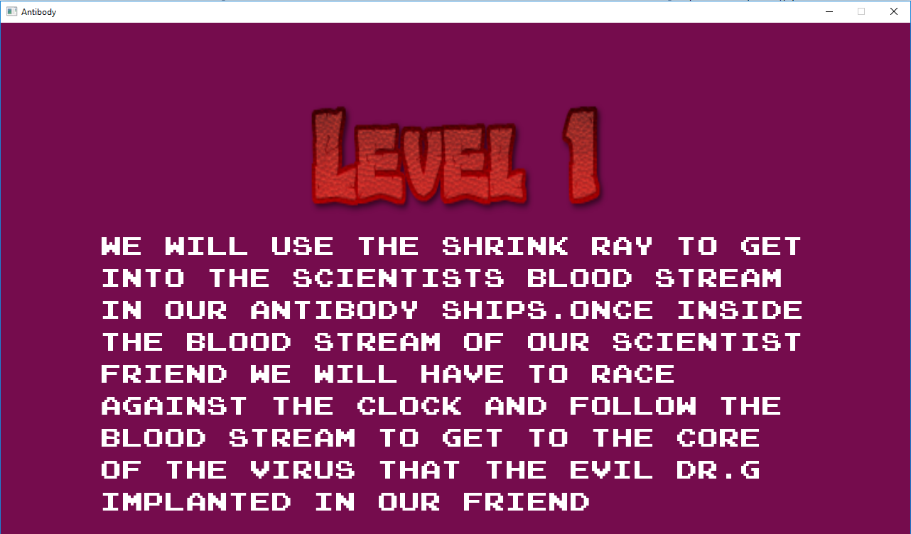
Figure 21 Level 1 Story Screen 2

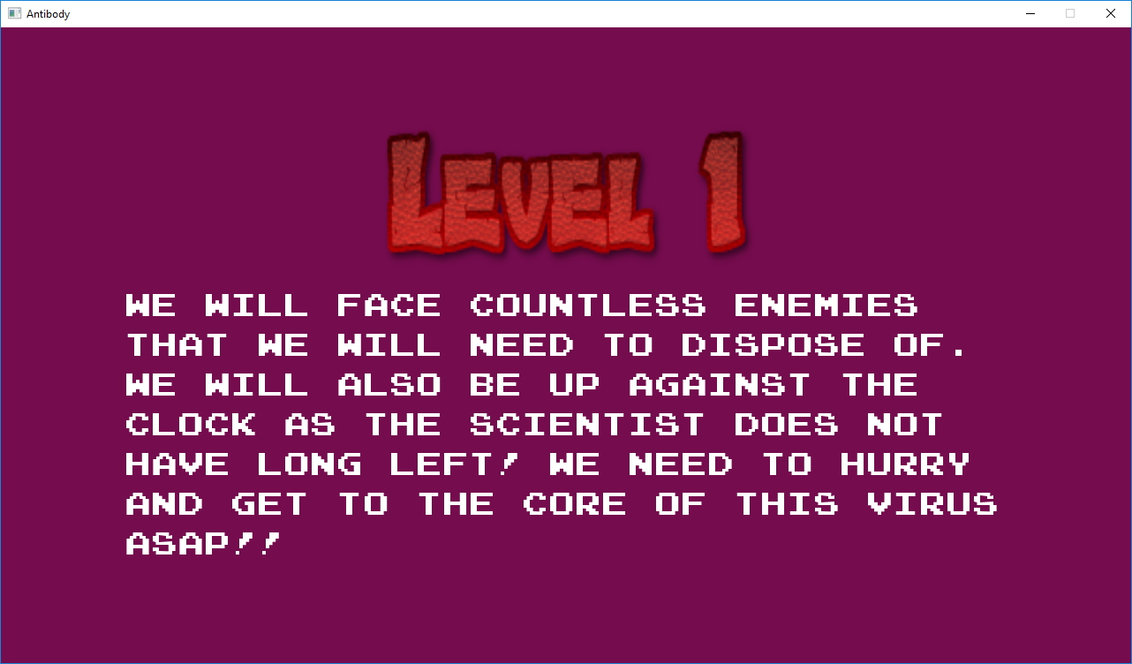
Figure 22 Level 1 Story Screen 3

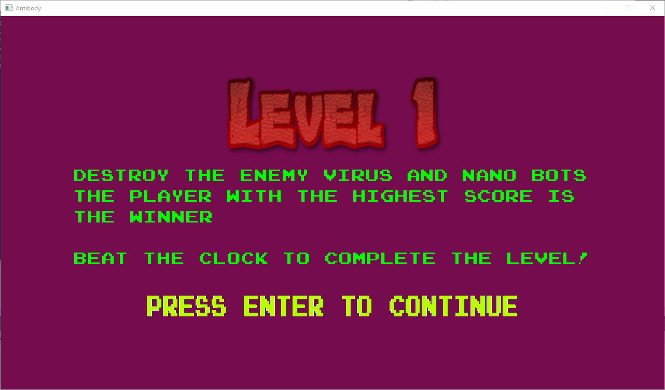
Figure 23 Level 1 Objective Screen

